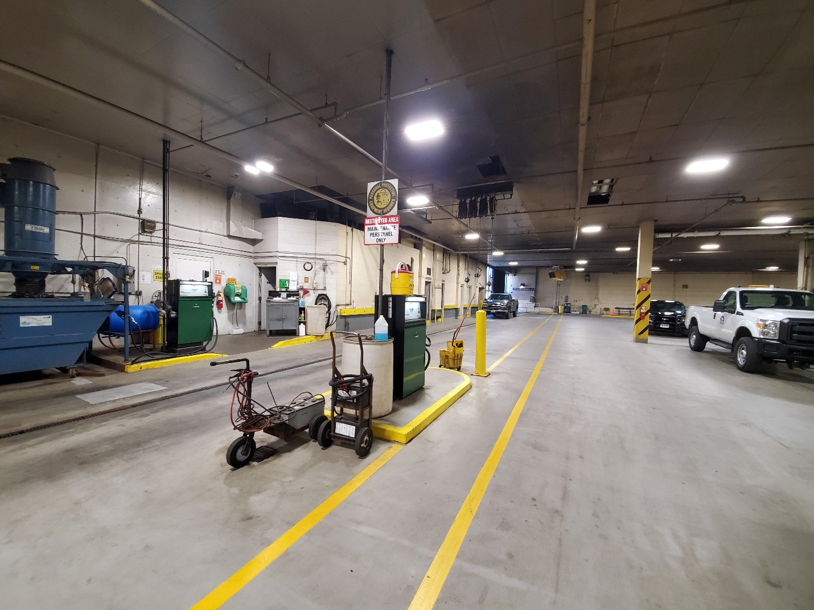

Fuel pumping stations supplying diesel fuel to the heavy duty buses. Fuel is piped from above. The DTA does not anticipate any work on the pipes or fuel pumping stations in the interior of the building.

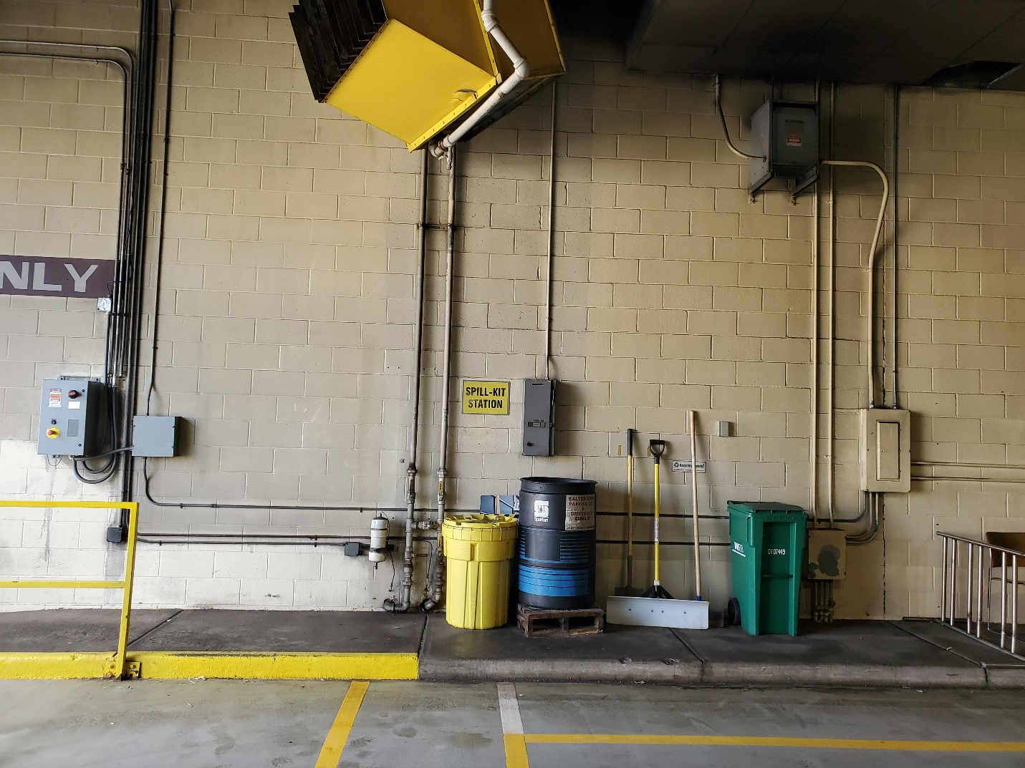

Pipes enter the building through the foundation and distribute fuel to the pumping stations. The VeederRoot controls are next to the pipes.

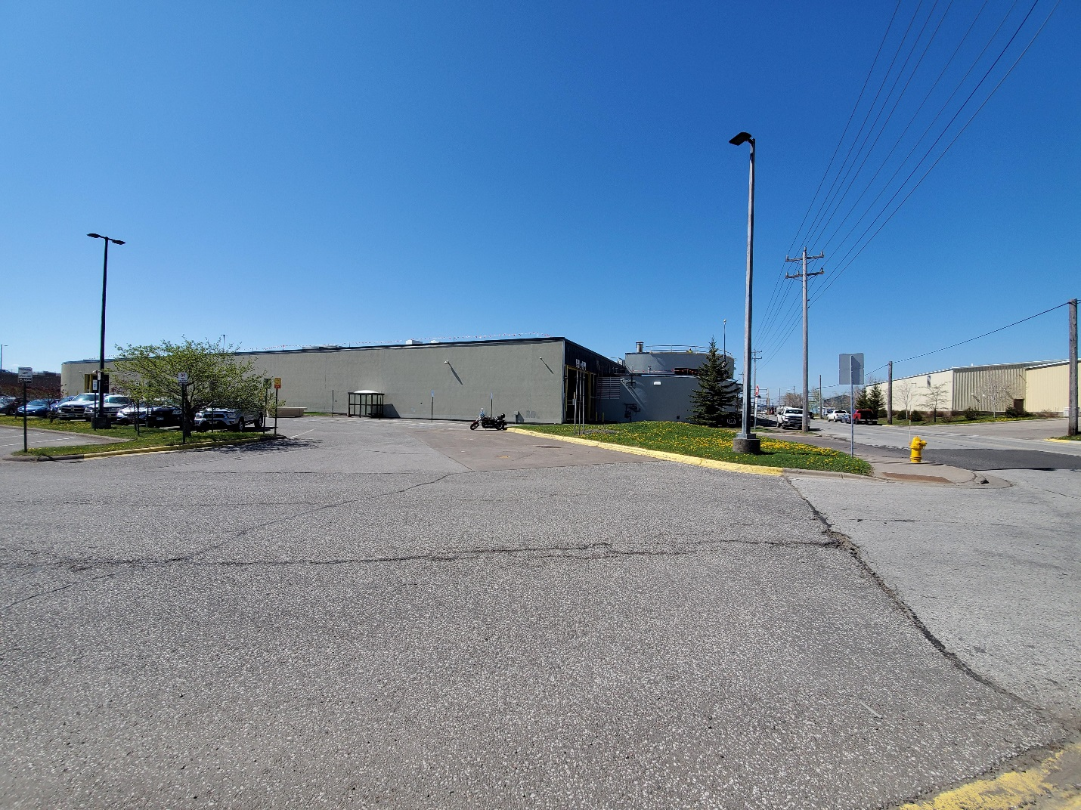

The underground tanks are located near the yellow painted curb.

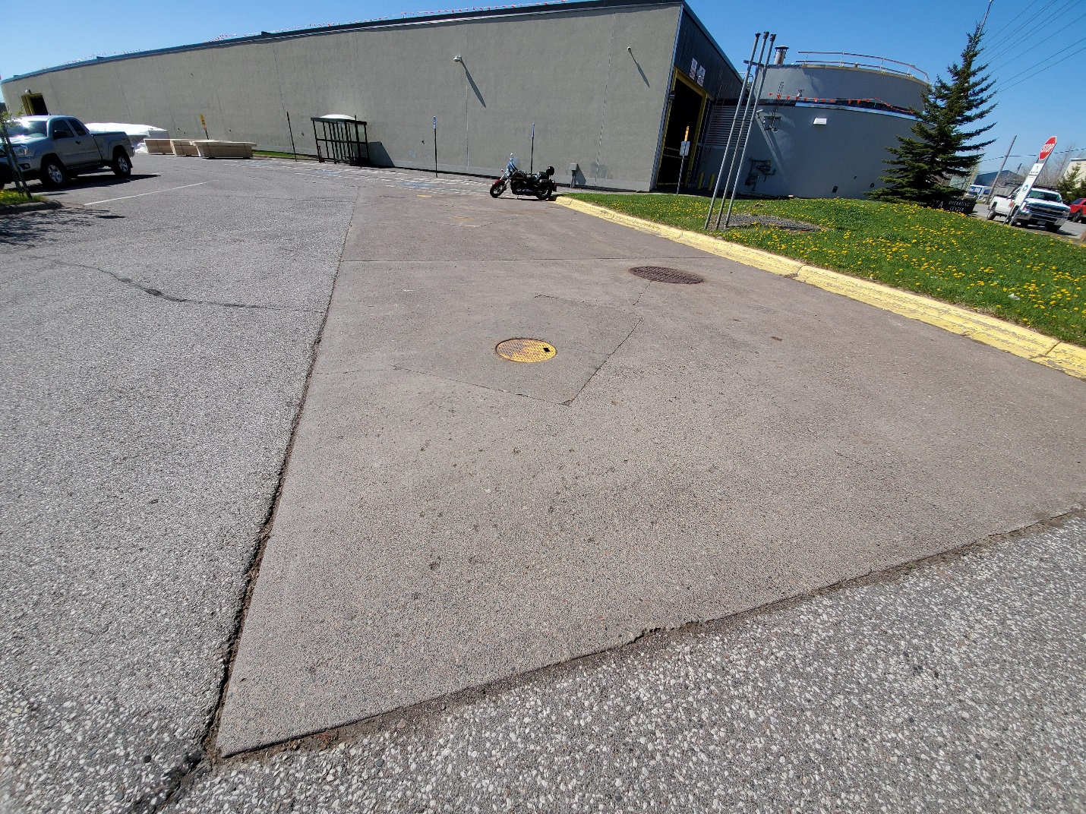

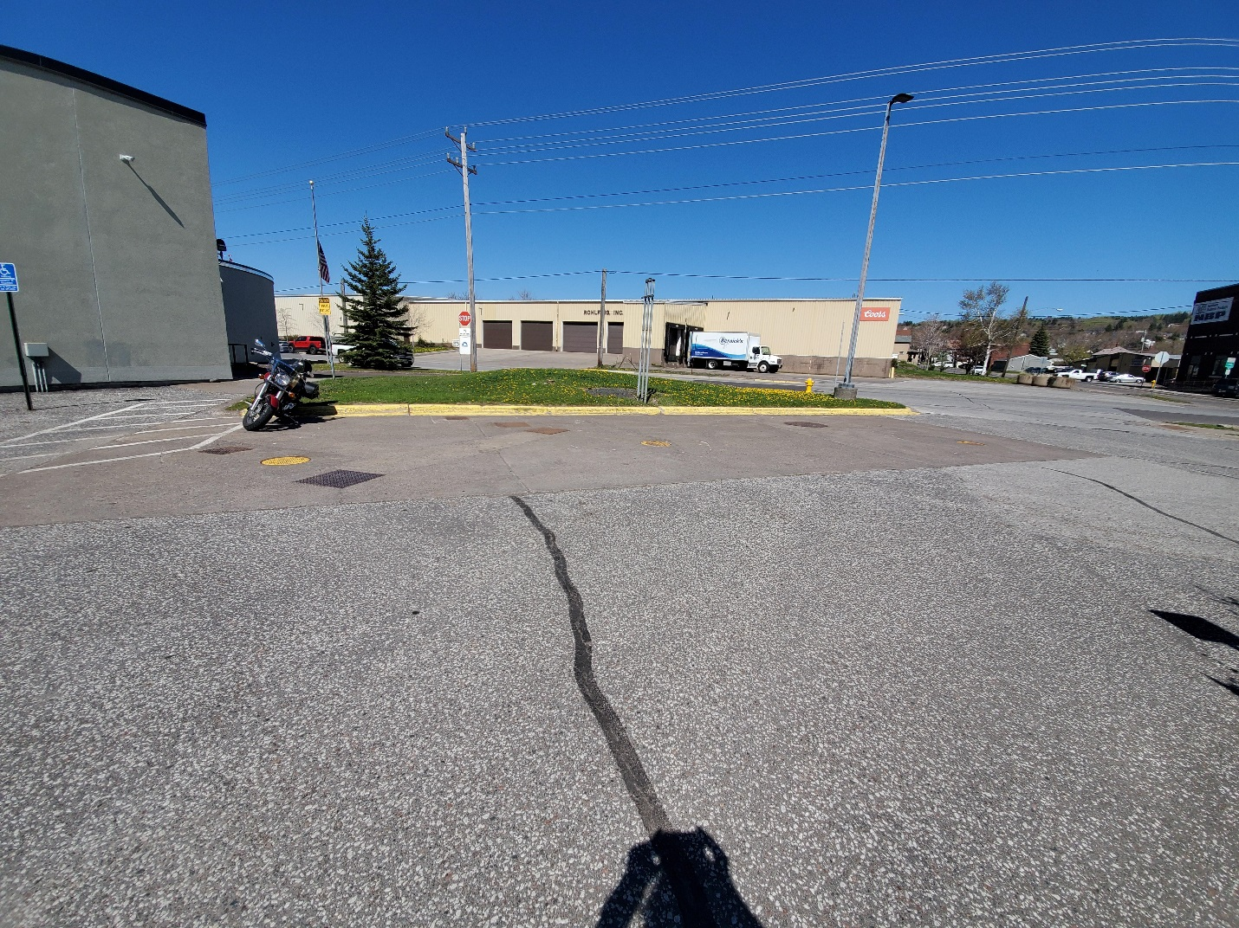

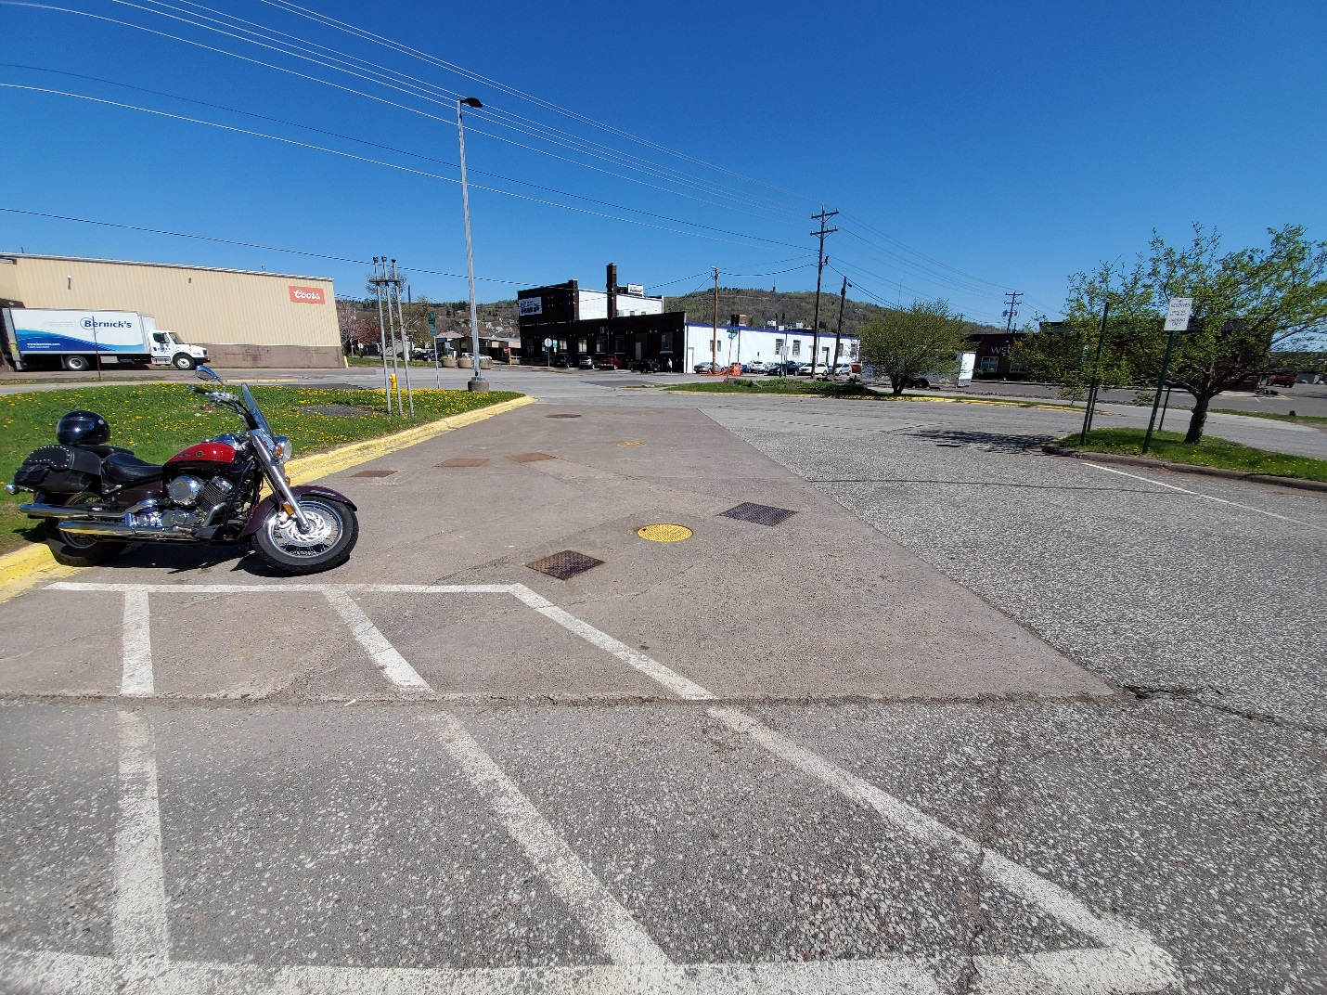

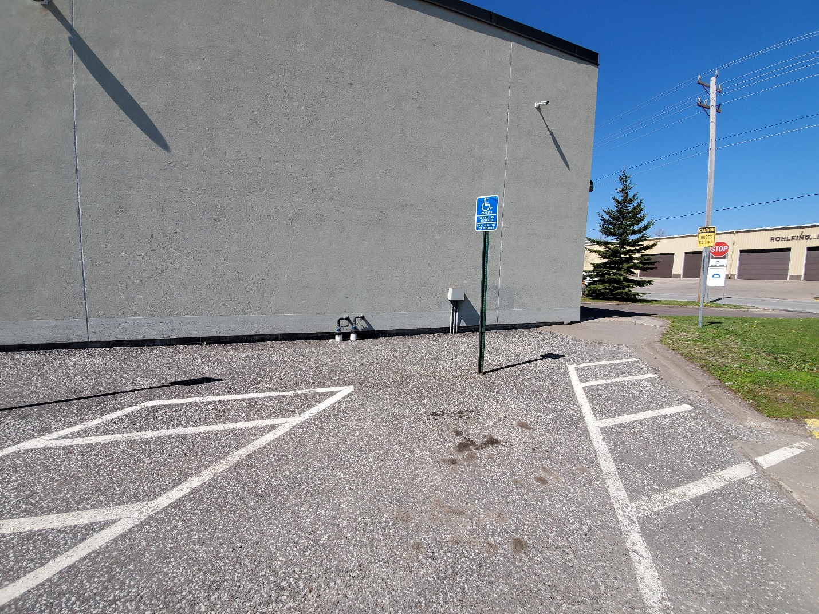

Pipes enter through the foundation. The VeederRoot controls are on the right.

Parking will be reconfigured after the new tanks are installed.